**E-Commerce Website**

**Developed Mega Mall Web Application**

**Index.php**

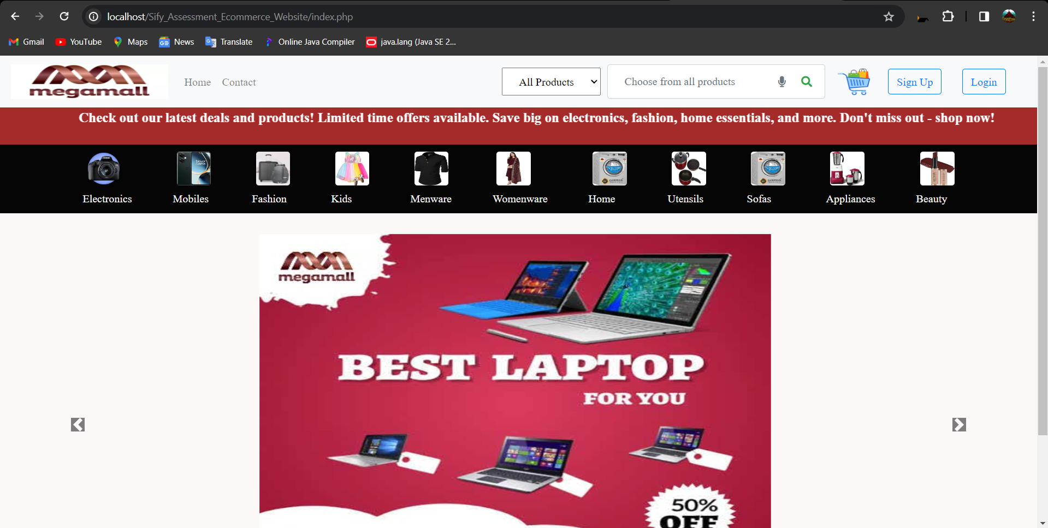

**Search the products with the names in the all products list or by other names like headphones,sofa,eye liner,laptops,camera,shirt etc..**

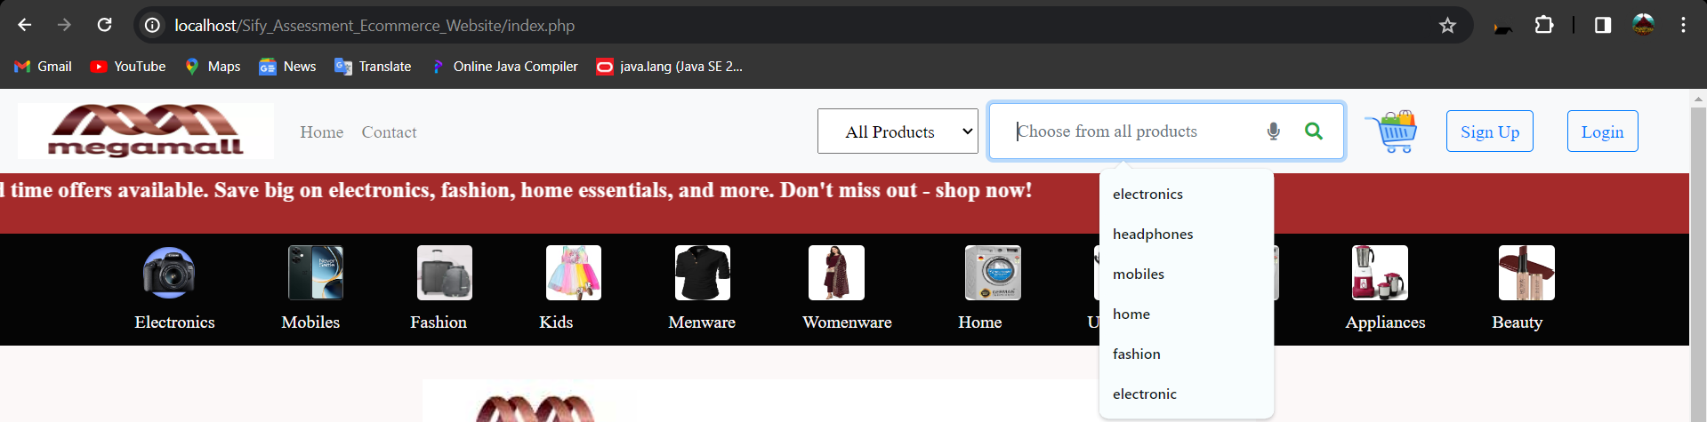

**Register.php**

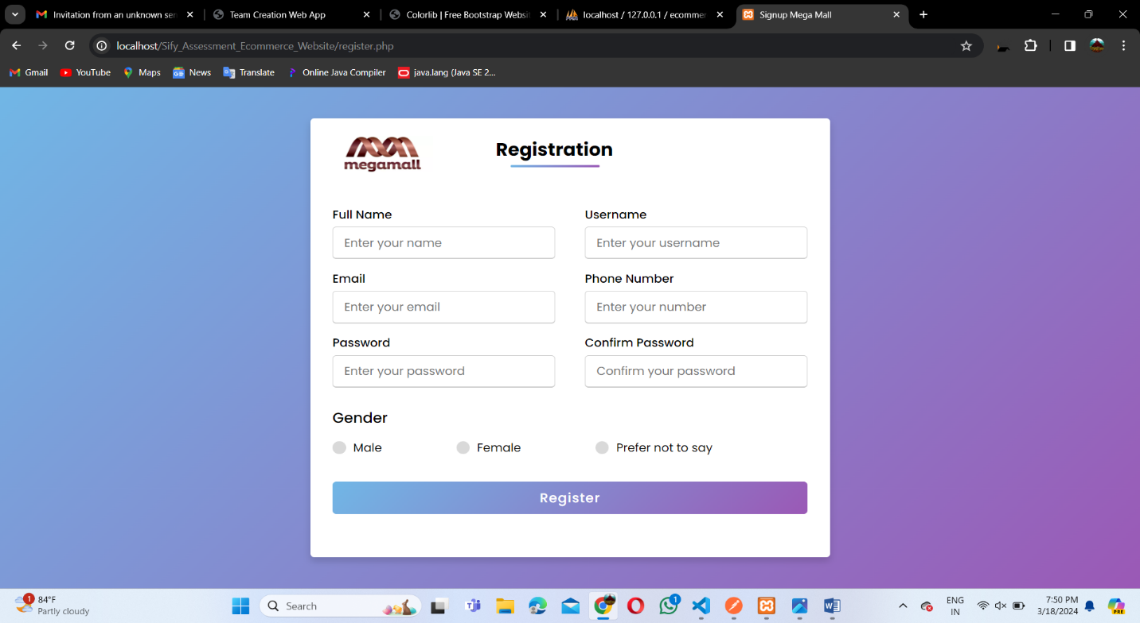

**Login.php**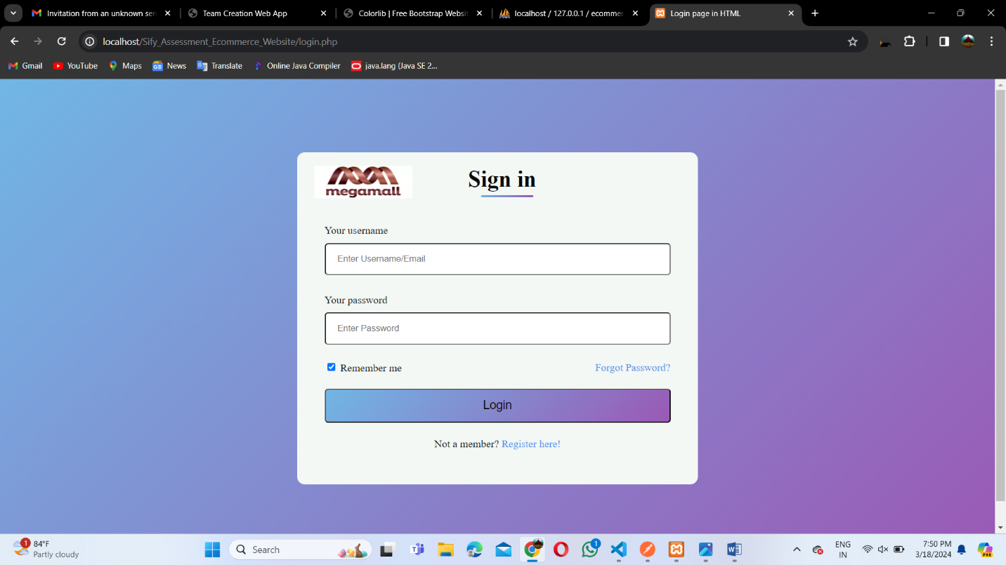

**Contact.php**

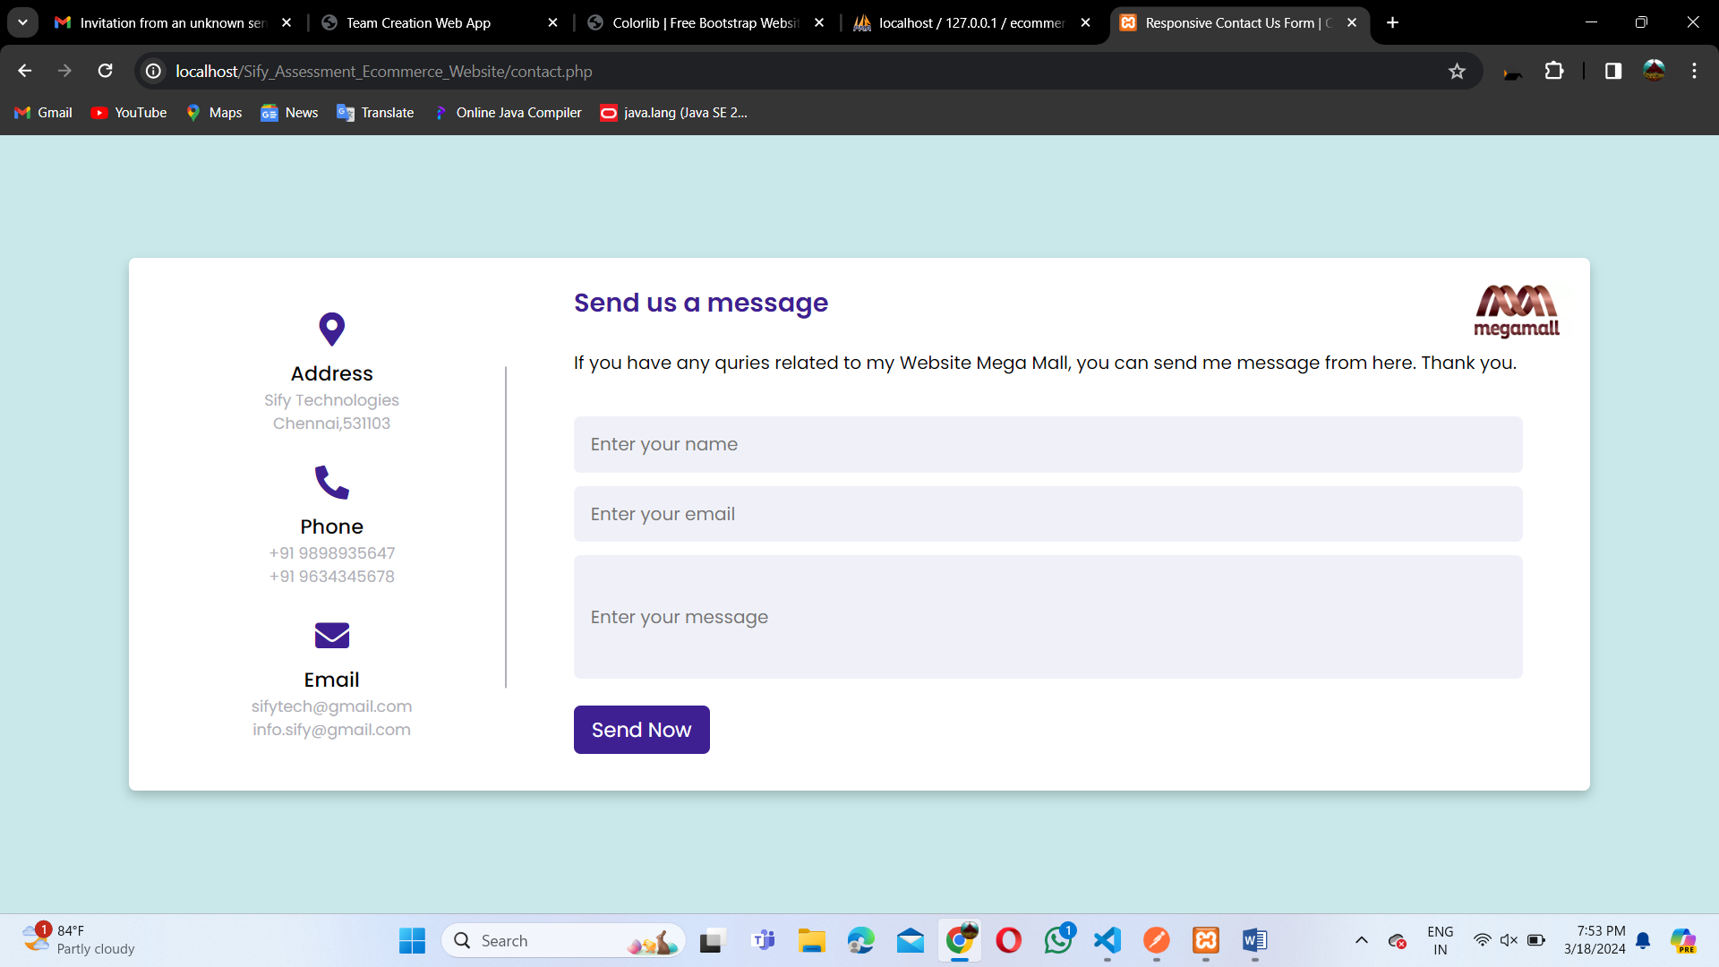

**Logging with the details after registration:**

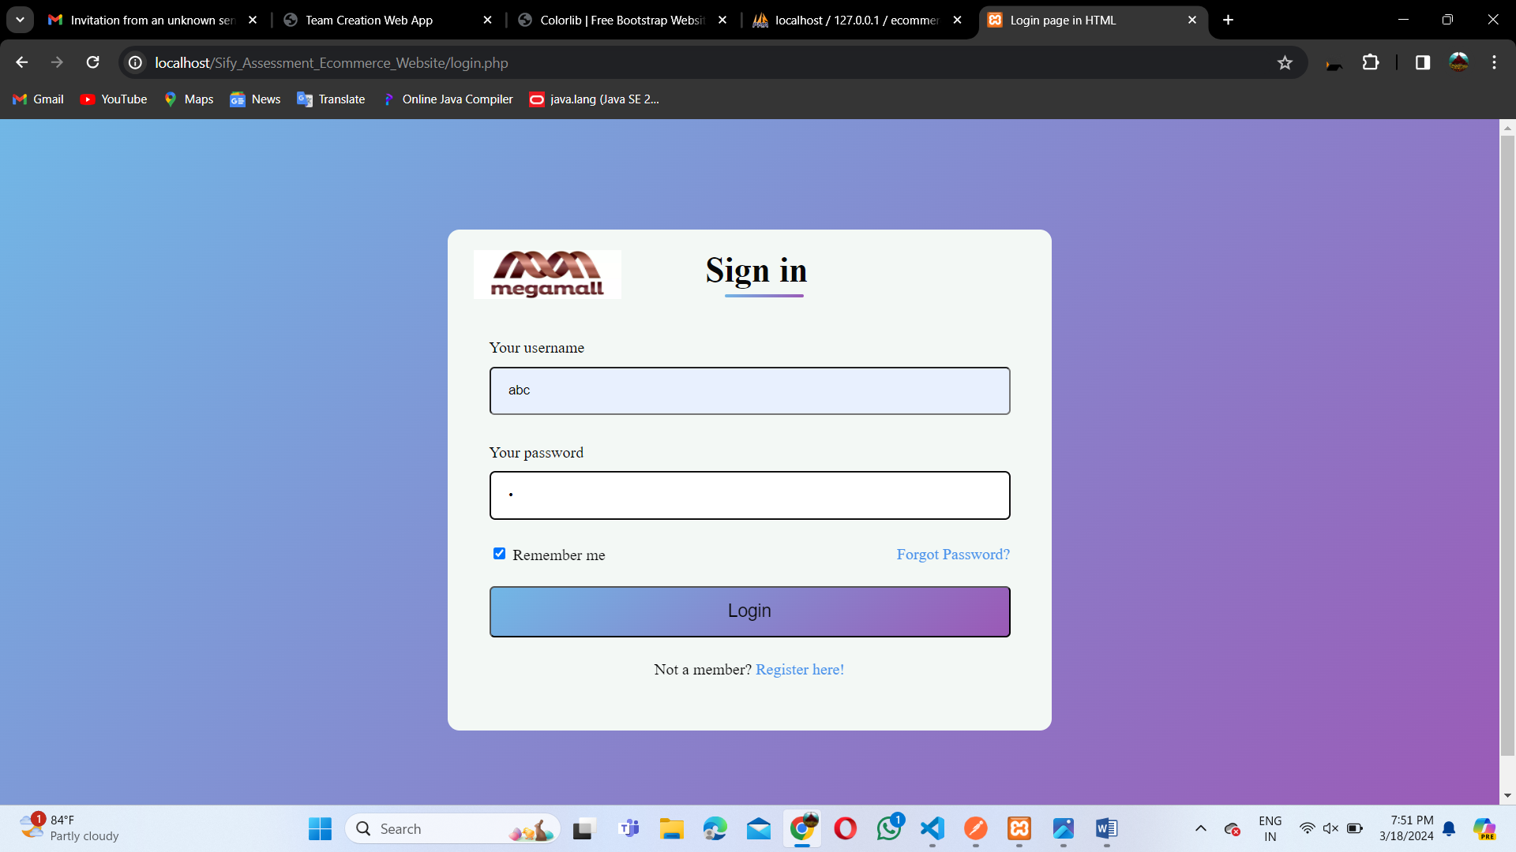

**User profile when clicked on my profile in the right corner**

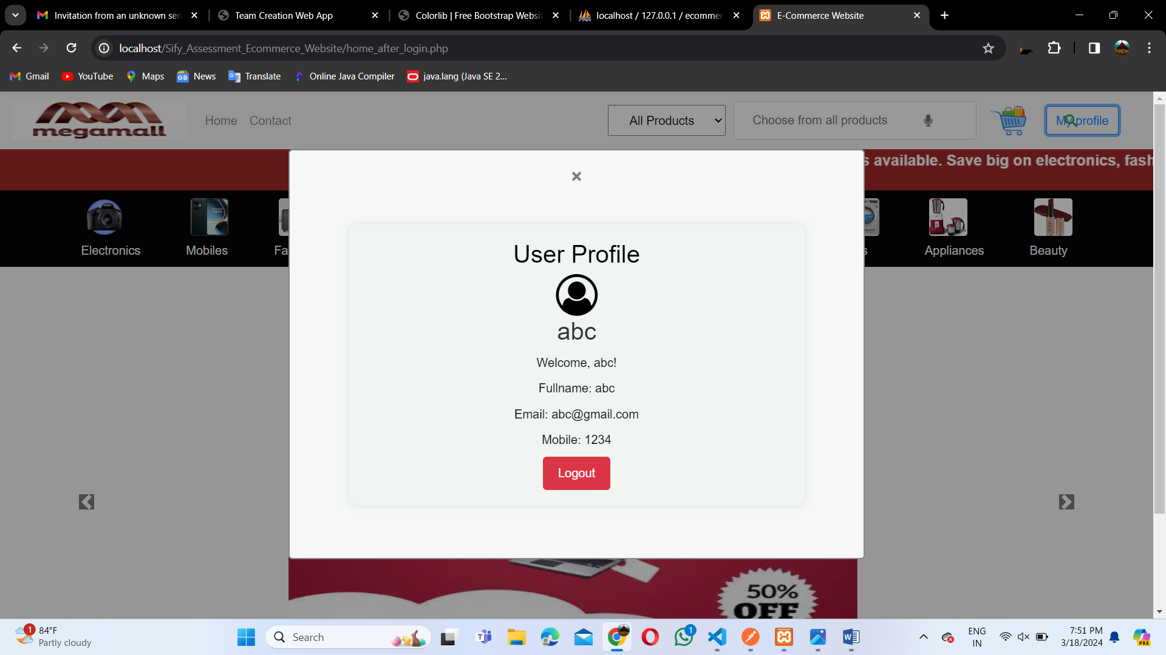

**After clicked on beauty in the toolbar**

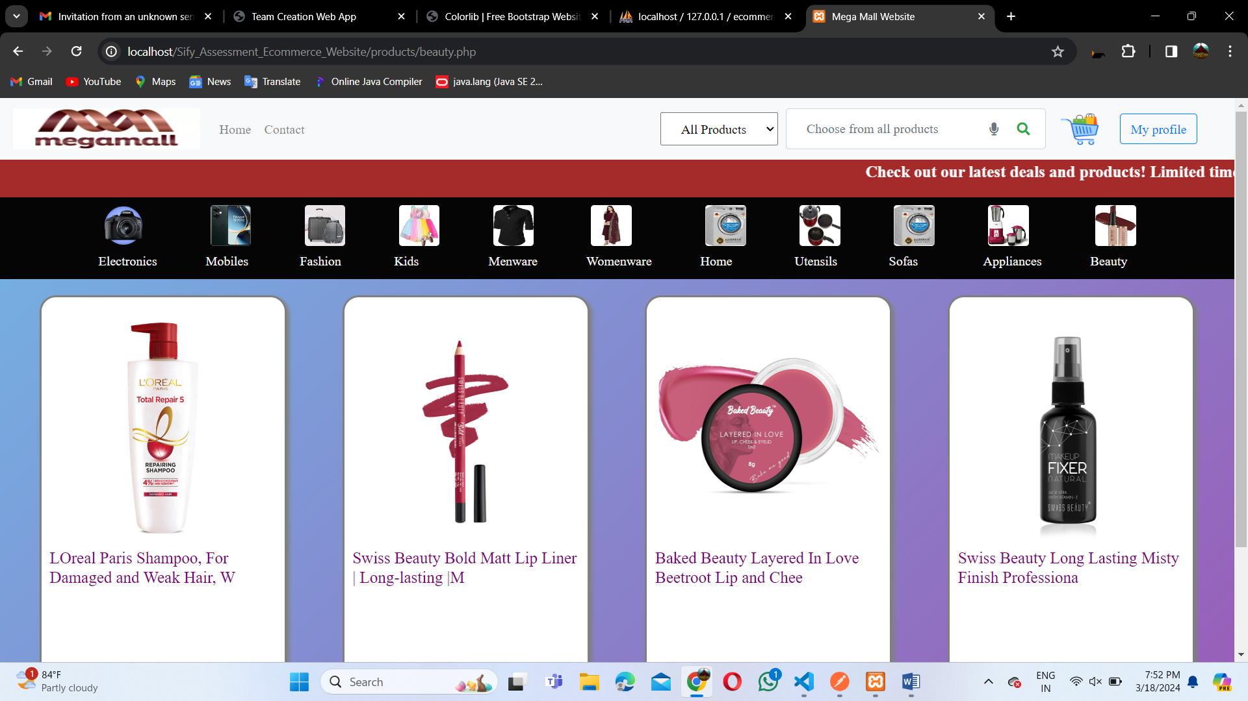

**After selecting a specific product**

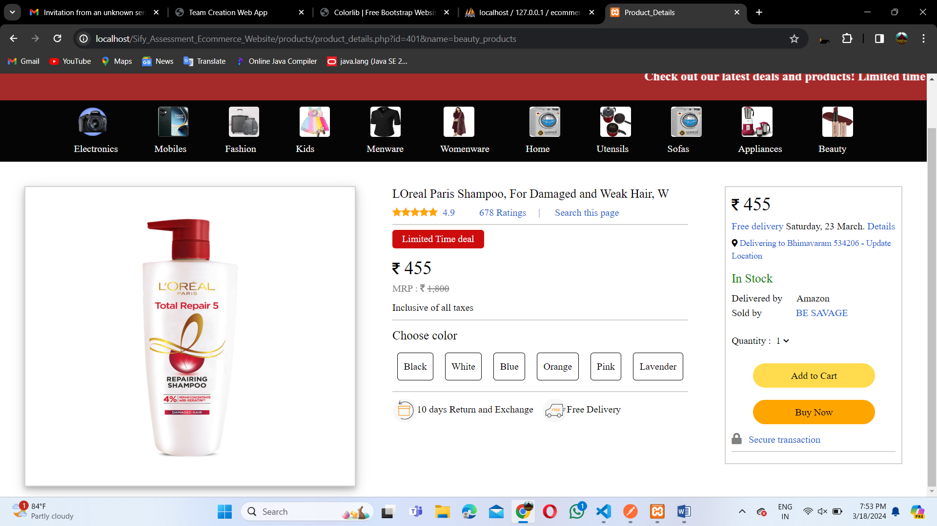

**Added to cart:**

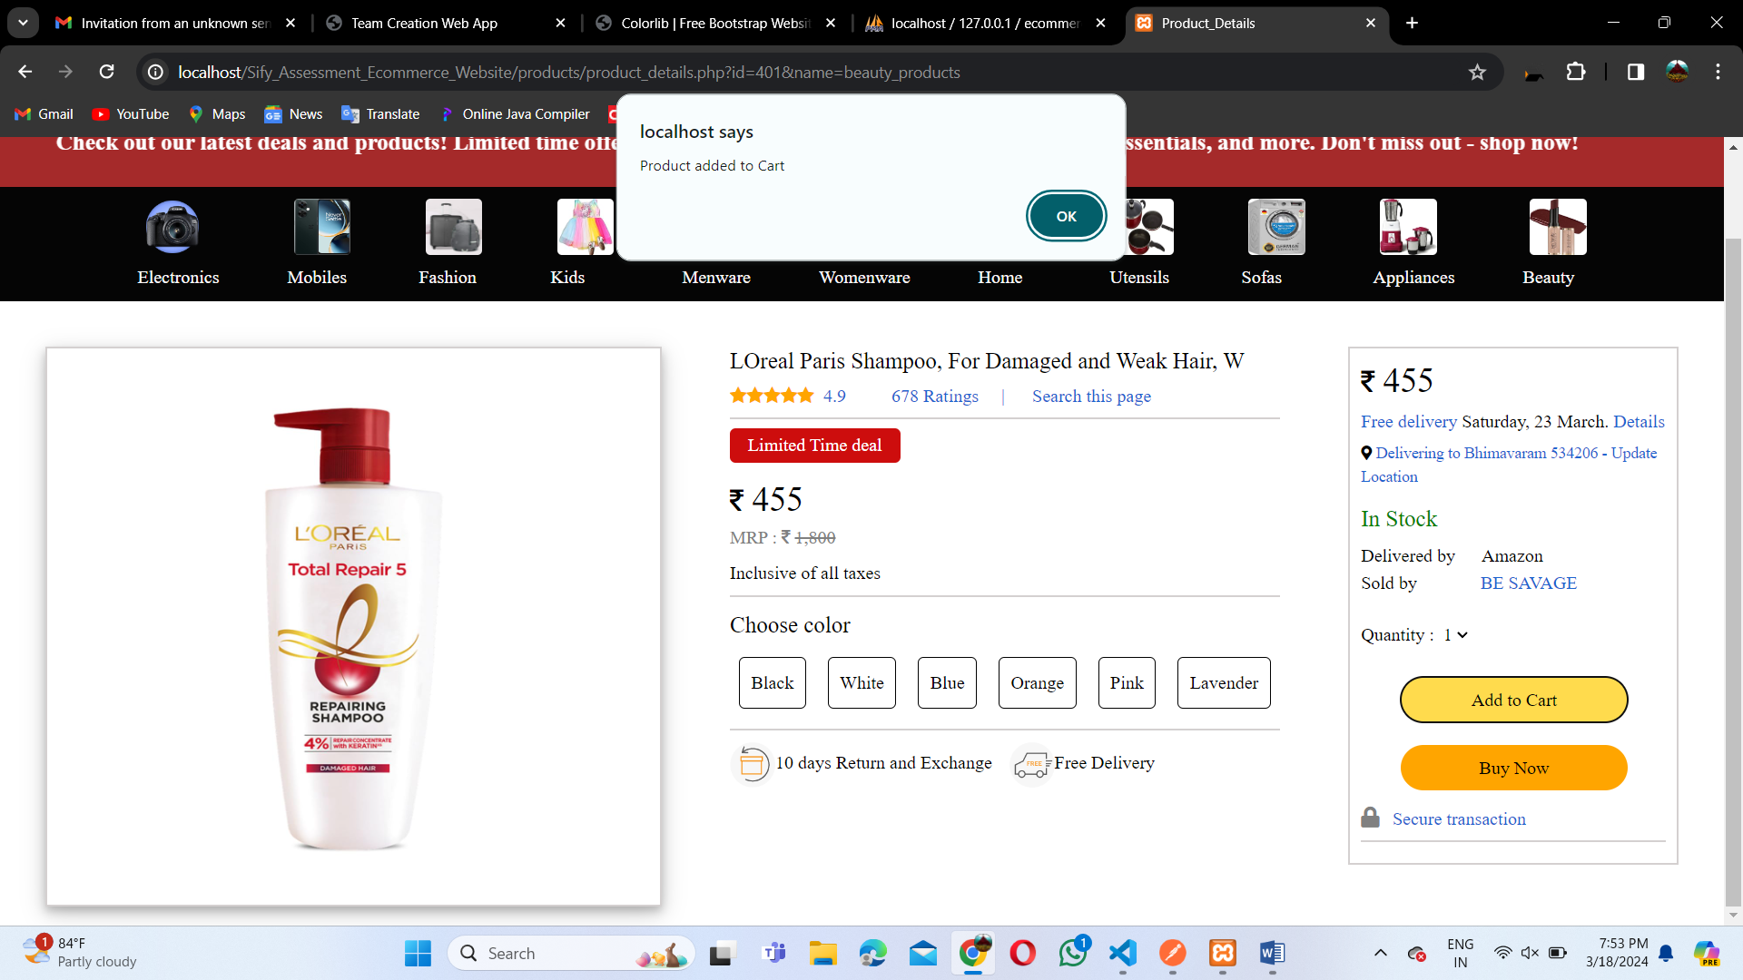

**Products/Electronics.php**

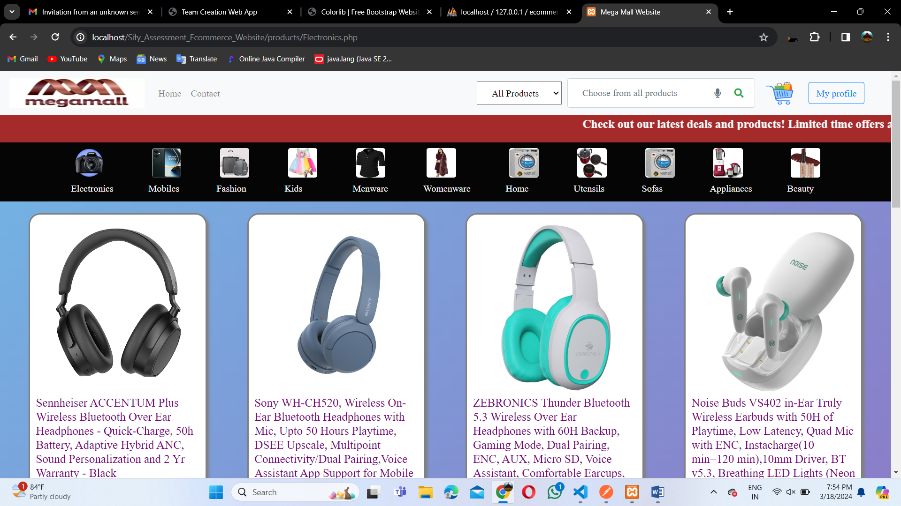

**Products/mobiles.php**

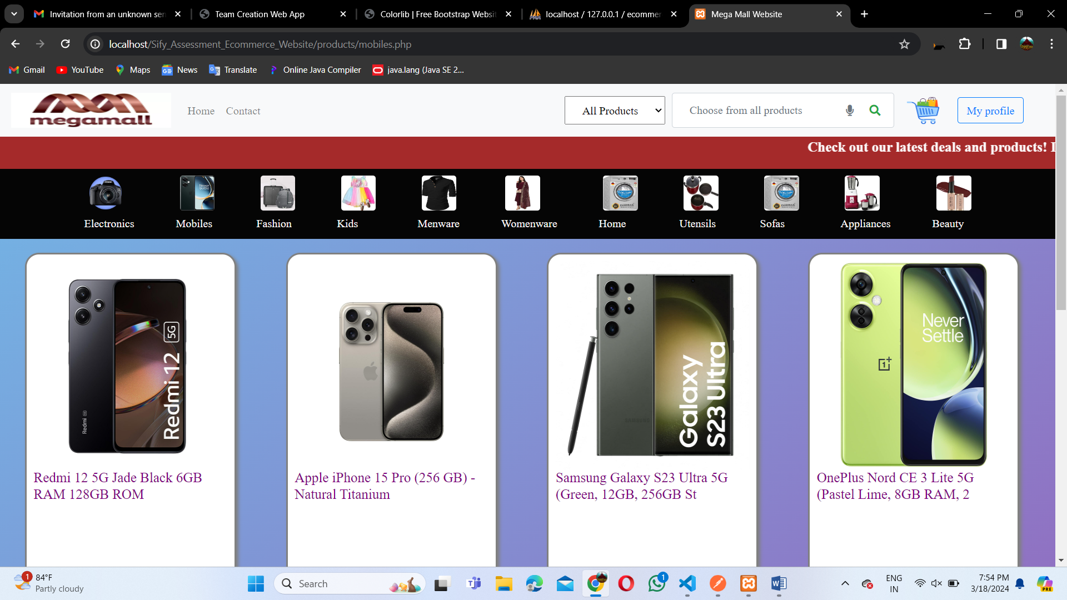

**Products/fashion.php:**

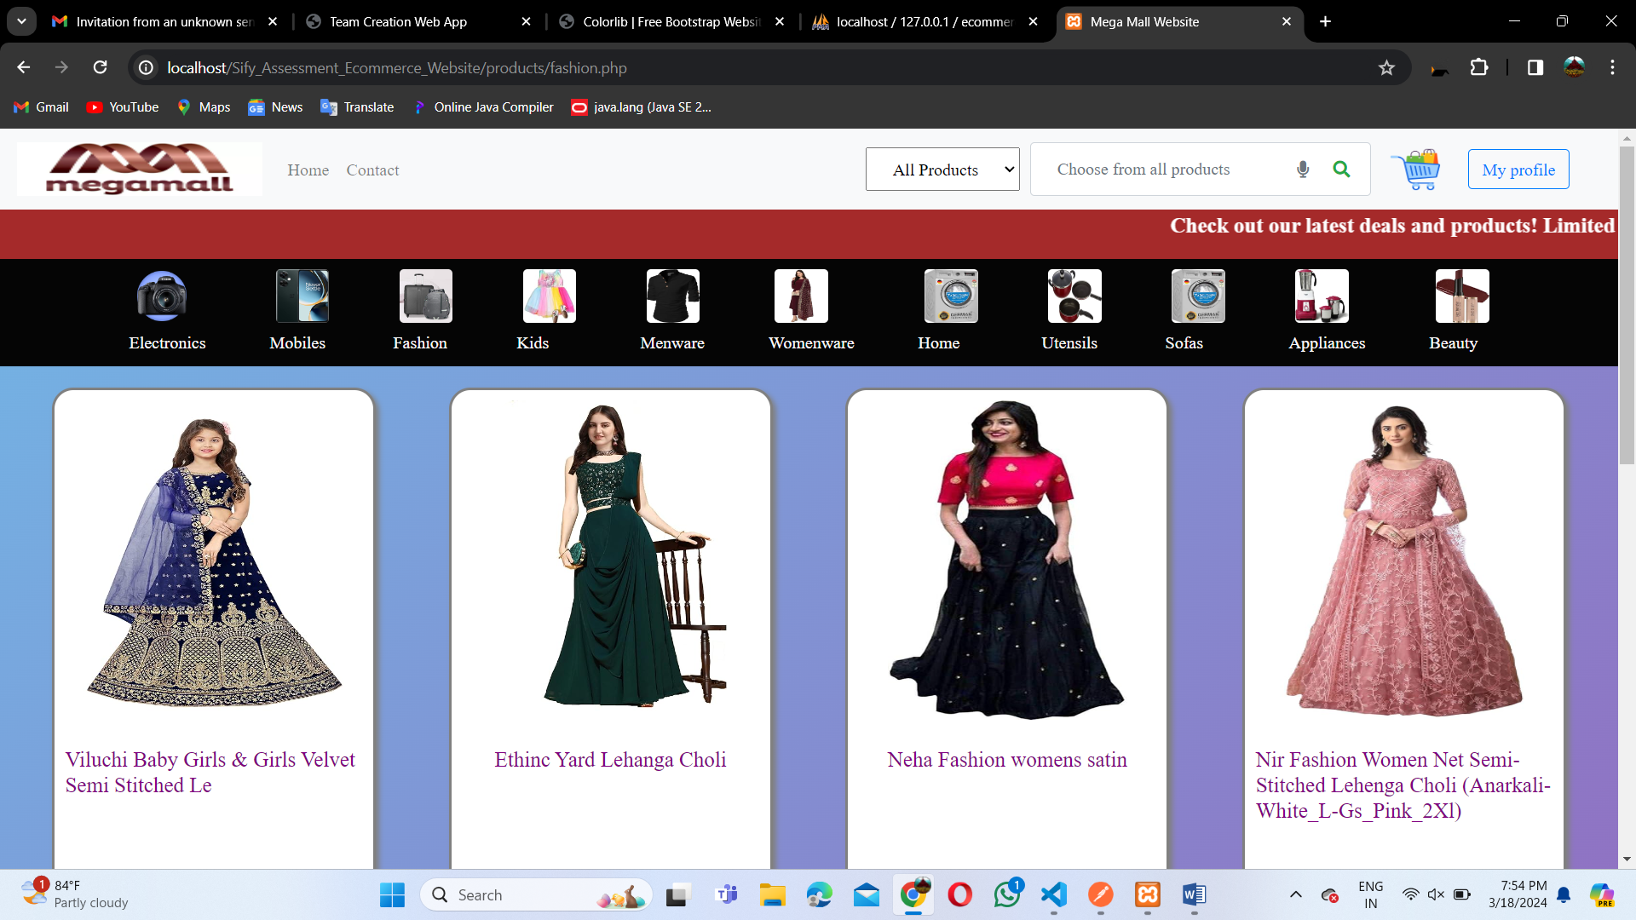

**Products/home_kitchen.php**

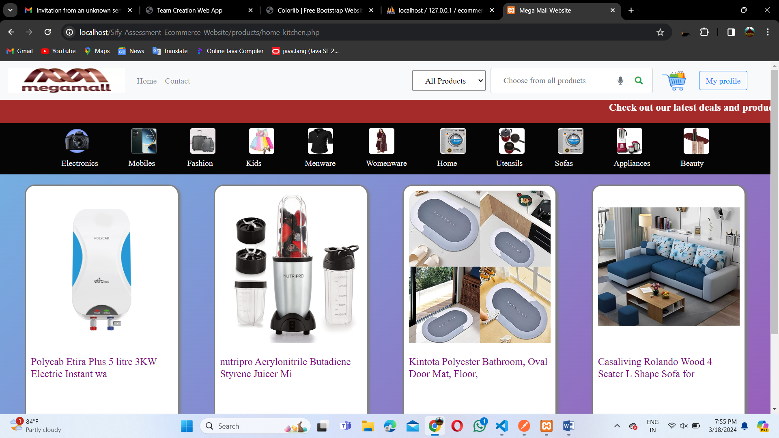

**Products/cart.php**

**Here the products are displayed whatever the user adds to cart**

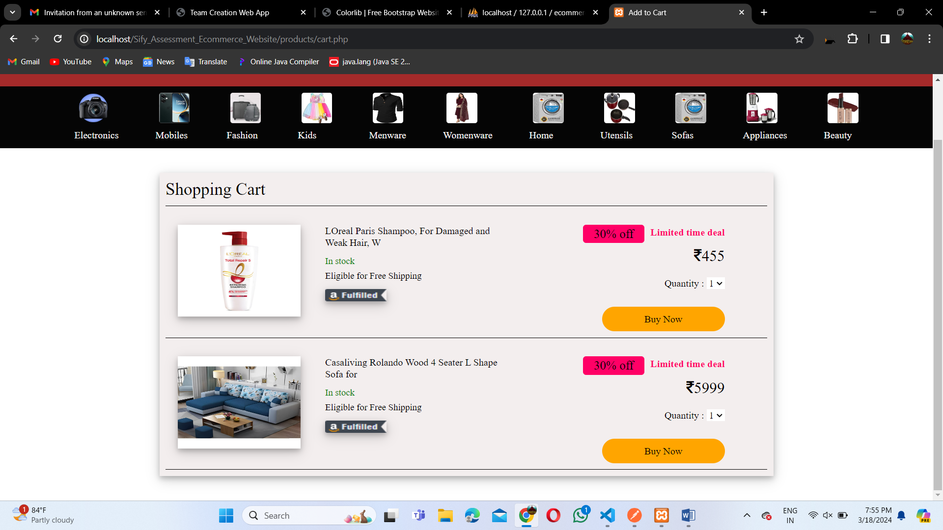

**Customer details**

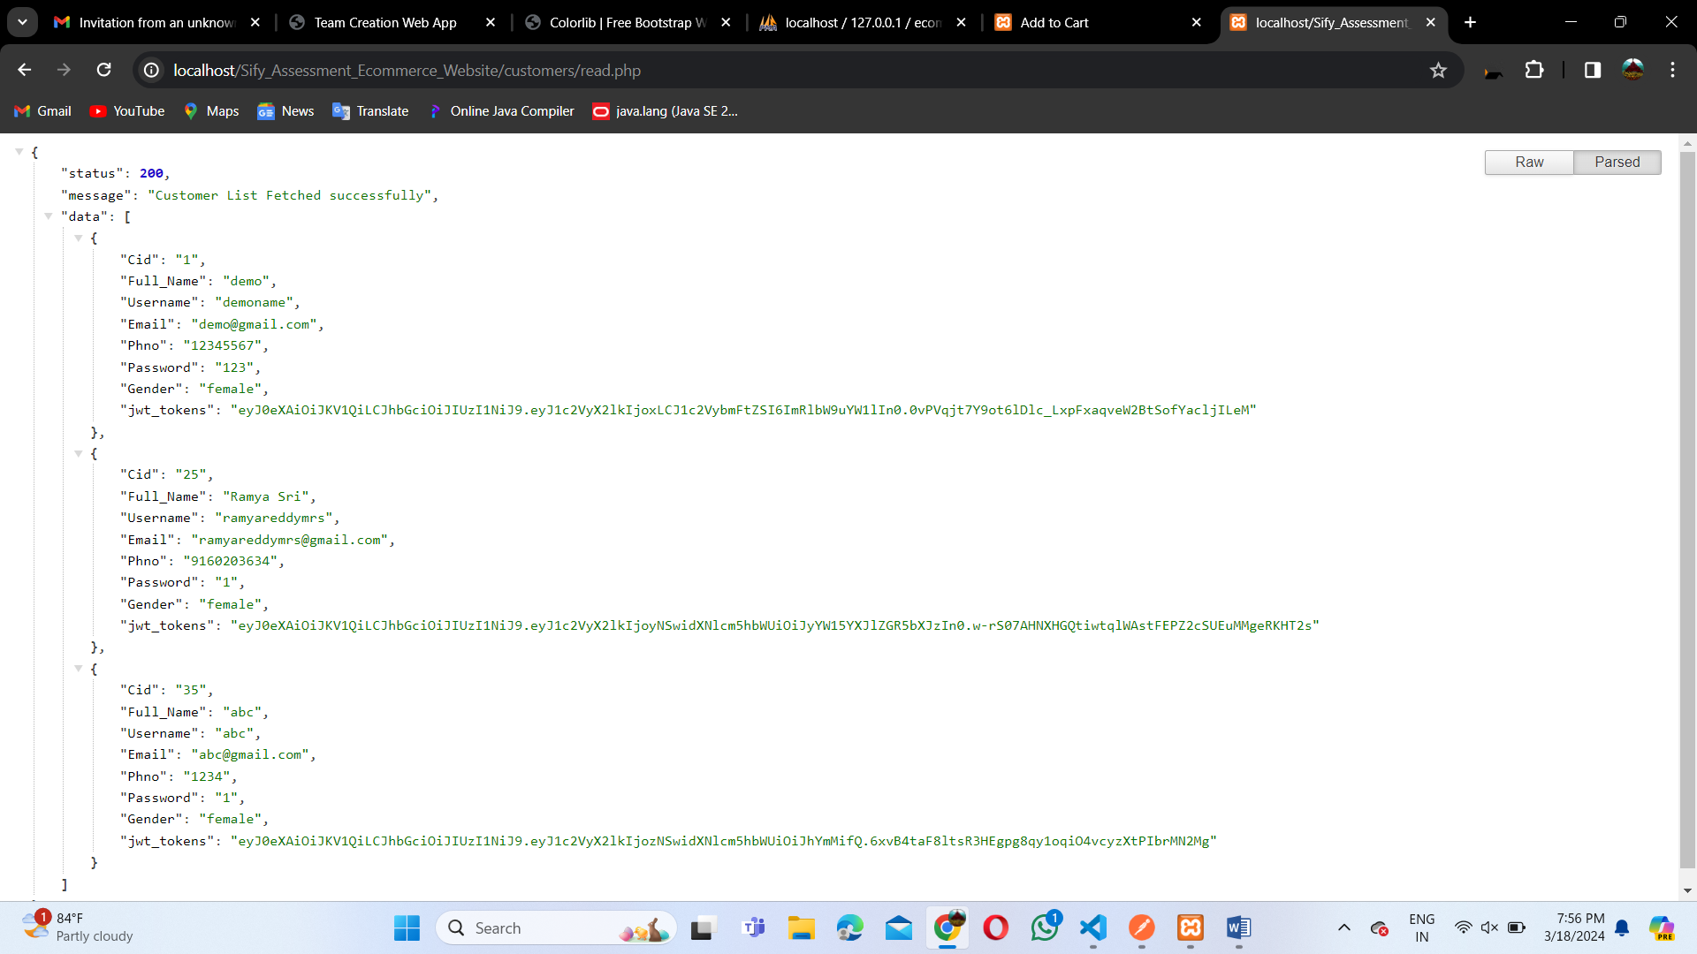

**Customer details in postman:**

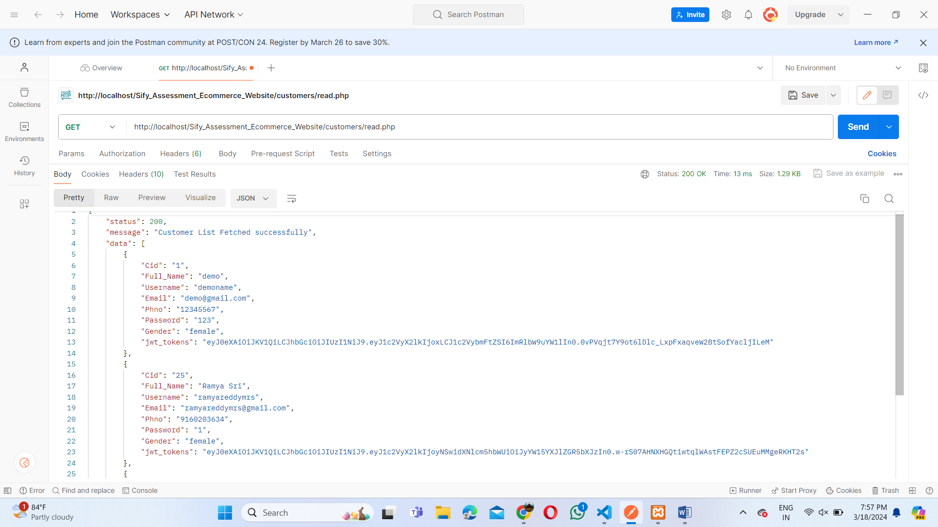

**Customer details fetched by id:**

